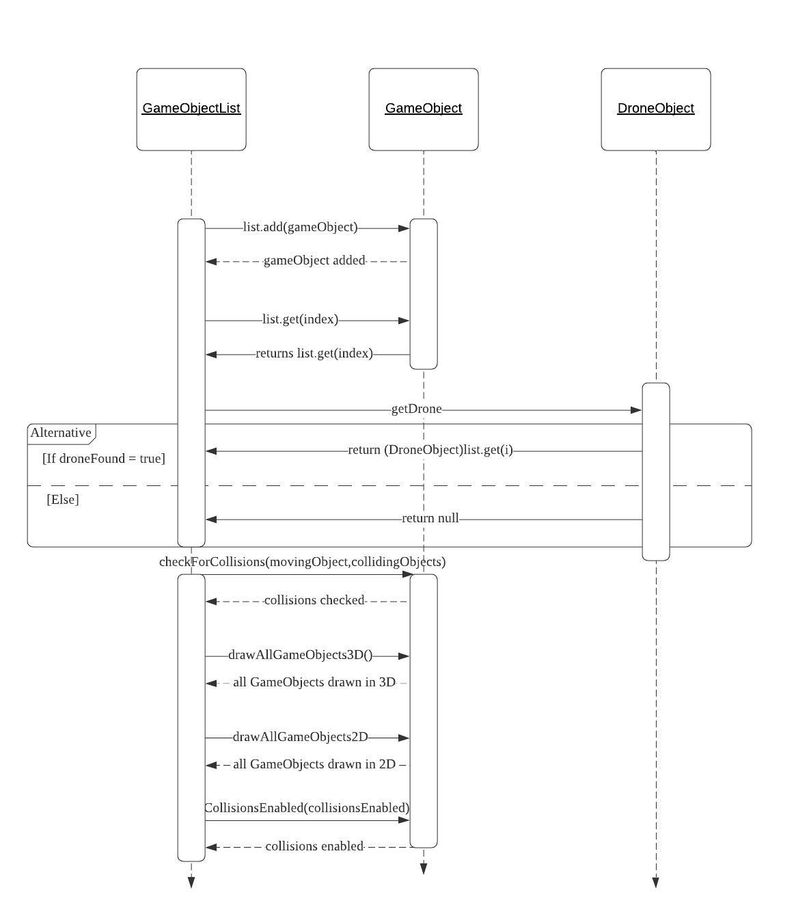

**Figure 1: UML sequence diagram for *GameObject***

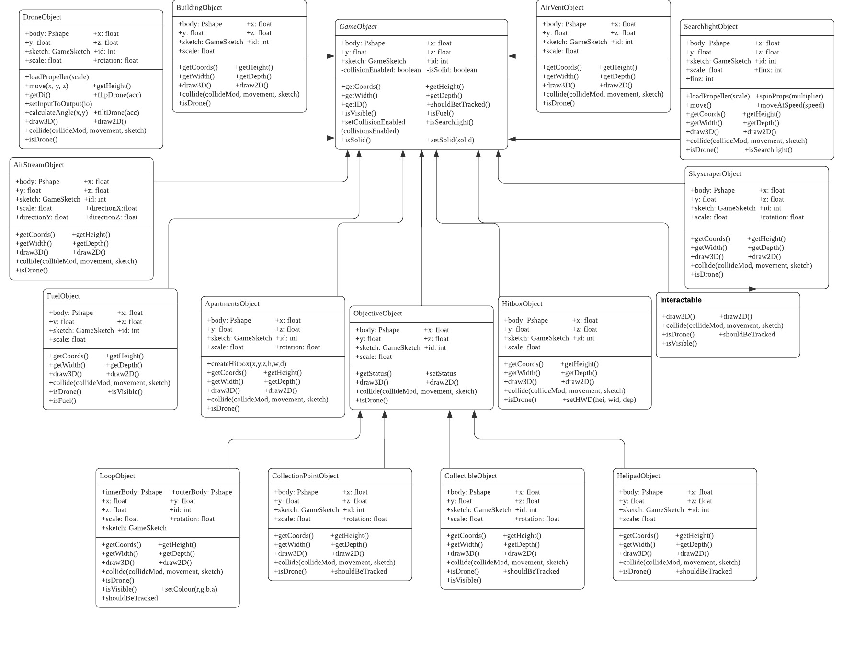

**Figure 2: UML class diagram for *GameObject***

We chose to create a static UML diagram and a dynamic UML diagram centered around the function *GameObject* which deals with all the different in-game objects’ position, velocity and collision. The reason for choosing these diagram representations is simply because it made both diagrams rather simple (albeit quite large for the static UML representation specifically) which in turn makes it easier to understand our design choices.

For example, the UML class diagram shows how all the different objects in the game are simply subclasses of *GameObject*, except for certain cases like *Loopobject*, *CollectionPointObject*, *CollectionObject* and *HelipadObject* who are subclasses of *ObjectiveObject*, which itself is a subclass of *GameObject*. Meanwhile, the UML sequence diagram shows the dynamic between *GameObjectList* and *GameObject*. It shows how all the different game objects are added in a list and added in-game. Since, as the UML class diagram shows, all objects are subclasses of *GameObject*, *GameObjectList* only needs to access *GameObject* and not each of the objects individually with the exception of *DroneObject* because it works a bit differently from the other objects. This makes the code shorter and much easier to read.

In general, these two UML diagrams convey the mentality we had throughout the project. While we had a complex task at hand, especially due to the limitations of the project, we still tried to make the code as short and easy as possible in order to implement new features or fix old features. With this project, we learned the importance of planning in advance the different modeling choices to make in a project as it allows the division of work to be more efficient compared to making the modeling choices as the project continues. Making diagrams of the project facilitates the comprehension of the project itself and makes it more structured as a whole. As a whole, this project made us understand how the development of software works in the industry.